

-2026)
Mrs.Swathi
Saisashank.B
2520030454
CSE
C0 -2 Multiway Trees & Range Query Structures

Case Study Topic CivicEye Complaint Analytics using B+ Tree

Work Done Summary

In this case study, we implemented a B+ Tree for the CivicEye Smart City Incident Monitoring & Response System. The B+ Tree stores complaint records in sorted order and helps users retrieve ticket details efficiently. The system performs fast range queries to display complaint records between

selected limits.

Implementation Details

Inserted complaint records into the B+ Tree structure.

Maintained sorted order using multiway tree balancing.

Performed range queries on complaint records.

Retrieved ticket details quickly for selected ranges.

Improved database indexing and searching efficiency.

Result Screenshot/Output

The B+ Tree provided efficient indexing and range query operations for TravelFlow booking management.
Travel ticket records were retrieved quickly within selected price ranges.
Compared to Binary Search Trees, B+ Trees performed better for large databases because all data nodes are linked sequentially for faster traversal.
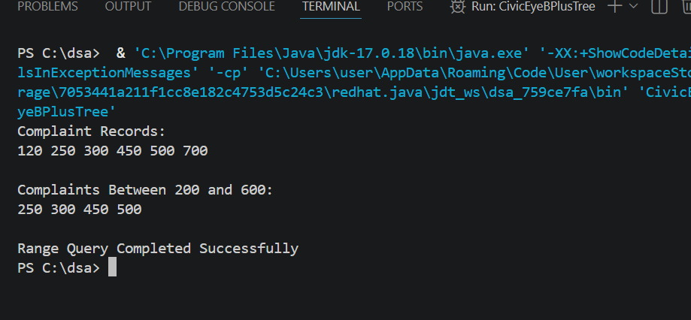
GitHub Link: https://github.com/saisashank-netizen

